Photos de Wikipedia :

1-Moro sphynx
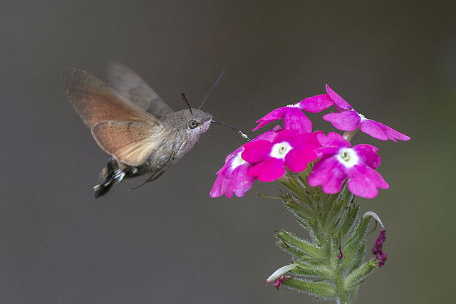

2-Bombylius major


